**Placement Profile**

**St. Michael’s Hospice (North Hampshire)**

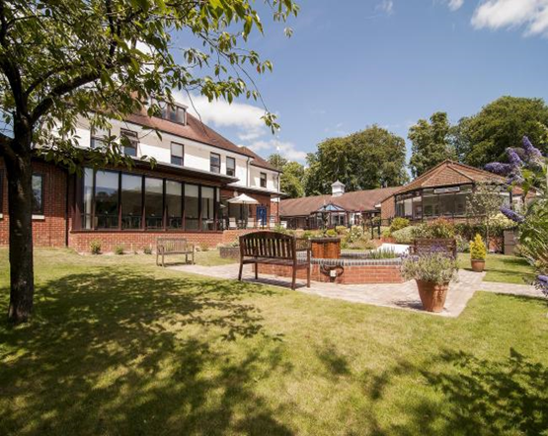Inpatient Unit and Hospice @ Home

Dear Student,

Welcome to St. Michael’s Hospice (North Hampshire).

We hope you will find your placement at St Michael’s Hospice (SMH) full of valuable learning experiences and that you enjoy your time with us.

You will be allocated a Practice Assessor who will oversee your placement, and work with different Practice Supervisors who will provide support, facilitate learning opportunities as well as feedback which will assist the final assessment. To get the most out of your placement it is important that you take responsibility for your own learning, identify your learning needs, pursue all available learning opportunities and utilise the support available. You should meet regularly with your assessor/supervisors to discuss your development and on-going needs.

Although you will have a nominated Practice Assessor, you will have an opportunity to work with everyone in the team, and all members are able to provide feedback on your progress. Your Practice Assessor will then add the feedback to your Practice Assessment Document (PAD).

This profile will provide information that will help you prepare for your placement. Please read it carefully and make contact with your placement area and your assessor/supervisor prior to the start of your placement.

On initial contact with us we will email you an electronic copy of the induction booklet that you will be provided with on your first day of placement which contains:

* Orientation to Placement
* Your Personal Development- Getting to Know You/ The VARK Questionnaire
* Learning Contract
* Understand the Staff Nurse Role
* Documentation
* Key SMH Policies and Procedures
* Handover
* Palliative Care
* Australia-modified Karnofsky Performance Scale (AKPS)
* Learning Opportunities and Outcomes
* Palliative care emergencies
* Commonly Used Drugs & Administration
* Common Abbreviations
* WHO Analgesic Ladder
* The use of laxatives in Palliative Care
* Calculating Tablets Quiz
* Calculating Mixtures and Solutions Quiz
* Palliative Care Drug Calculations

We will also email you an electronic copy of the following documents, which you will be provided with, and will require completion on your first day of placement:

* Student Information Form
* Student Welcome letter
* COVID-19 Guidance and Information for Students
* St. Michael’s Hospice COVID-19 Staff Risk Assessment

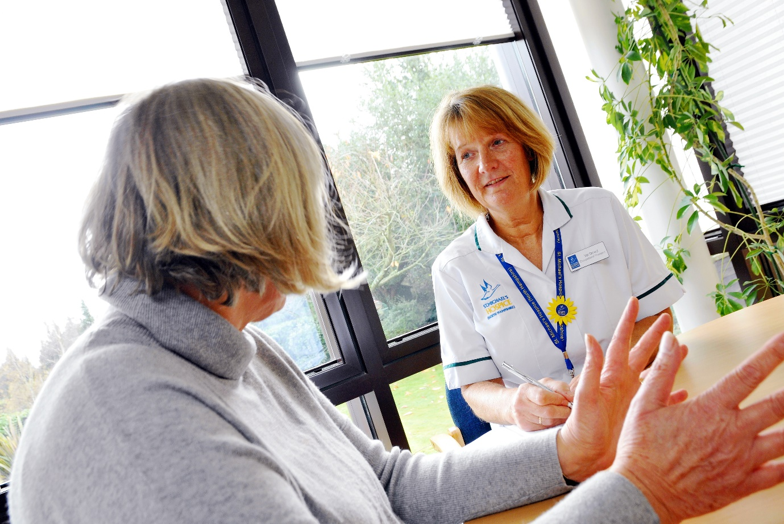

**Welcome to St. Michael’s Hospice.**

**About Us**

Why We Care:

St. Michael's Hospice was established in 1991 by a committee led by former Mayor Margaret Weston. Their mission was simple, to offer a choice and understanding of complex conditions in the dying. Over 25 years later and caring for over 500 patients a year across the community, St. Michael's leads the provision of the highest quality palliative care throughout North Hampshire and offers more choice than ever. The spirit, ambition and drive presented by the founding committee continue in our staff to this day and remain at the heart of all our work.

Our Mission Statement

St. Michael’s Hospice (North Hampshire) enables anyone faced with a life-limiting illness, their families and carers, to attain the highest possible quality of life by providing a choice of specialist care and support.

Our Vision

St. Michael’s Hospice will endeavour to influence and lead all aspects of palliative care provision in North Hampshire. It will do this by working in partnership with all stakeholders, particularly service users, who will be actively involved in the development and delivery of services which, as far as possible, will be user led.

The Area We Cover

St. Michael’s Hospice is in Basingstoke but serves all North Hampshire.

The majority of patients who are referred to St. Michael’s are suffering with cancer-related conditions, but care is also provided for those with other chronic life-limiting illnesses. The Hospice’s clinical team works tirelessly with patients to ensure they have the highest possible quality of life, whether care is delivered by the Hospice at Home Team or during a stay at our In-Patient Unit.

The Hospice at Home Team work in collaboration with community healthcare professionals to support and deliver our patients’ preferred choices in care. Whilst our priority is to ensure that the best possible care is provided, consideration is always taken with regards to our patients’ families and friends; our specialist healthcare professionals are committed to sharing knowledge and information that will aid their understanding and ability to support the patient.

Quality Accounts

Quality Accounts are produced to enhance public accountability to an organisation such at St. Michael's Hospice which provides patient services.

St. Michael's Hospice Quality Account is available for download at https://www.stmichaelshospice.org.uk/resources.html

Patron

The Earl of Portsmouth DL officially became Patron in 2009 after supporting St. Michael’s Hospice for many years.

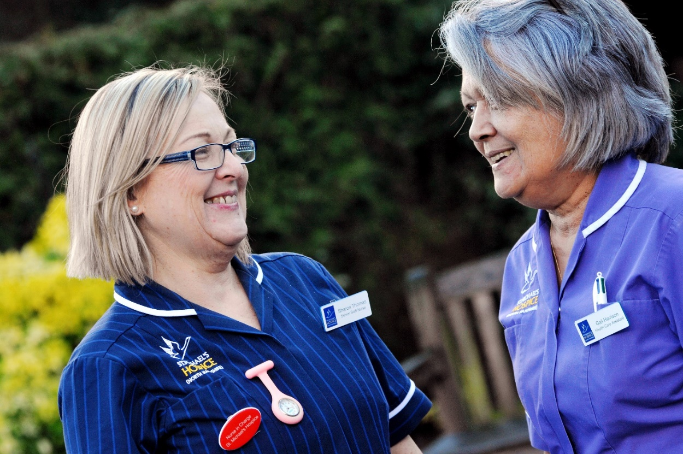

**Our Vision – Our Values**





St. Michael’s Hospice (North Hampshire) will endeavor to influence

and lead all aspects of palliative care provision in North Hampshire.

It will do this by working in partnership with all stakeholders, particularly service users, who will actively participate to develop and deliver services which, as far as possible, will be user led.



People

At the heart of all we do

All our actions put the patient at the centre

Treating relatives, colleagues and supporters with the same compassion as our patients



Respect

Value each other, caring for people as individuals and treating people with compassion

Judging every issue by considering the outcome for people, promoting their wellbeing and safety

Providing a supportive working environment aligned to best employment practice

Supporting and collaborating with colleagues, showing commitment to working together



Integrity

Openness and honesty in communication in a non-threatening environment

Making time to support one another in our roles and learning from others experience

Respecting confidentiality and accepting personal responsibility

Maintaining the highest standards of behaviour and accountability



Diversity

Understanding that each individual is unique and can contribute to the success of our organization

Practicing mutual respect for qualities that are different from our own

Understanding that diversity includes not only ways of being but also ways of knowing

Speaking well of each other and celebrating the diversity of our individual roles



Excellence

Professional at all times, aspiring to be the best we can be in everything that we do

Exceeding expectations and putting our community at the center of everything we do

Celebrating our successes and appreciating our staff, volunteers and patients



**How to find us:**

St. Michael’s Hospice

Basil de Ferranti House, Aldermaston Road

Basingstoke, Hampshire RG24 9NB

T: 01256 844744 E: [info@stmichaelshospice.org.uk](mailto:info@stmichaelshospice.org.uk)

St. Michael’s Hospice is based 1.8 miles north of Basingstoke town, and is across the road from Basingstoke Hospital. There is good road access from Junction 6 of the M3 and good public transport links from Basingstoke town centre.

Rail

Basingstoke railway station is approximately 50 minutes from London Waterloo and 40 minutes from Eastleigh railway station and is located in the town centre.

Taxi

A taxi rank is located outside of Basingstoke Railway Station with journeys to St. Michael’s Hospice costing approximately £6.

Bus

Stagecoach buses are available at the front of the railway station

The ‘link’ service operates every 30min from 08:00 in the direction of either Kingsclere or Newbury.

Car

From M3 Junction 6

•Exit M3 at Junction 6 and at the roundabout follow signs to Basingstoke/Alton/A339 (2nd exit)

•At Black Dam Roundabout, take the 2nd exit onto Ring Road E/A339

•After 1.5 miles take the left exit for Aldermaston/A340

•At the Aldermaston roundabout take 4th exit onto Aldermaston Road/A340

•Pass through two sets of traffic lights and turn left (there is a white St. Michael’s Hospice sign on the corner)

•After 100m turn left into St. Michael’s Hospice.

**Who to contact before starting placement:**

The phone number for the hospice is: 01256 844744

* St. Michael’s Hospice Administration Team:

[hh-ft.smhadmin@nhs.net](mailto:hh-ft.smhadmin@nhs.net)

* Clare Turner, Ward Manager

[clare.turner@stmichaelshospice.org.uk](mailto:clare.turner@stmichaelshospice.org.uk)

* Lucy Whyle, Deputy Lead Nurse, Hospice @ Home

[Lucy.whyle@stmichaelshospice.org.uk](mailto:Lucy.whyle@stmichaelshospice.org.uk)

**Shift patterns on the Inpatient Unit:**

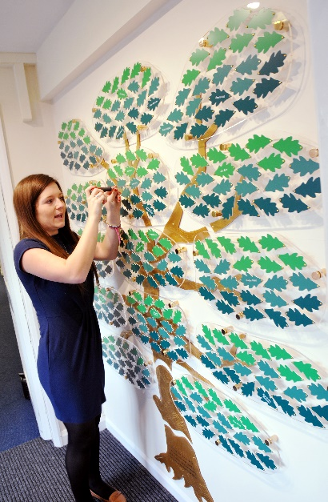There are four nursing shifts:

**Early:** 0730 - 1530

**Late:** 1330 – 2130

**Long Day:** 0730 - 2000

**Nights:** 1930 – 0800

**Shift patterns for Hospice@Home:**

There are three nursing shifts:

**Early:** 0830 - 1630

**Late:** 1140 – 2100

**Long Day:** 0830 – 2100

**Our facilities:**

There is a staff room with lockers, a staff fridge, sandwich toaster and microwave. You can order food from our kitchen at a very affordable price and you can easily access the hospital or ARC conference centre to purchase food.

Parking is on site and is free.

**Description of the teams/professionals who work there:**

* Hospice at Hope Team
* Inpatient unit
* Therapists
* Social Worker
* HHft Community Palliative Care Team
* Complementary therapy
* Chaplaincy
* Family Support Team
* MND clinic
* Fundraising
* Marketing
* Retail

**The learning opportunities in our area:**

* Care of the dying
* Pain management
* Symptom management
* Palliative care drugs
* Palliative care emergencies
* Syringe Drivers
* Palliative care in the community
* Spiritual care
* Advanced communication skills
* The multi-disciplinary team
* Disease processes
* Complimentary therapies
* Last offices
* Bereavement
* Psychological support of both patient and families
* Admissions and discharges

**Preparatory reading prior to placement start:**

It may be useful for you to read around the following areas before your placement:

* Pleural aspiration
* Paracentesis
* Syringe drivers
* Motor neurone disease
* Holistic assessment
* Symptom management
* Metastatic Spinal Cord Compression (MSCC)
* Hypercalcaemia
* SVC Obstruction
* Raised Intracranial Pressure
* Neutropenic sepsis

## Online resources and self-directed learning

1. **Palliative Care Guidelines**

<https://book.pallcare.info/>

These Guidelines represent a general reflection of current local practice in palliative care to be used in conjunction with the British National Formulary, the Palliative Care Formulary, The Oxford Textbook of Palliative Medicine, The Oxford Handbook of Palliative Care and other comprehensive texts. Although aimed at non-specialist doctors and nurses some of the material is more suitable for those with a specialist interest.

1. **Wessex Palliative Guidelines (green book)**

The Palliative Care Handbook (the “Green book”) is a pocket-sized handbook produced in association with all the Wessex specialist palliative care units. It contains advice on many aspects of specialist palliative care, including symptom control. It is particularly useful to give away to non-specialists, for example when teaching medical students and junior doctors.

Although the content of all versions of the handbook throughout the region is exactly the same, each unit’s handbook has a slightly different cover – the front shows which unit it came from and the back bears useful telephone numbers for that service.

1. **Earl of Mountbatten Hospice**

The hospice on the Isle of Wight has some extremely useful and user friendly palliative care symptom control guidelines on their website:

<https://www.mountbatten.org.uk/page/clinical-guidelines.html>

1. **Oxford Handbook of Palliative Care**

The Oxford Handbook of Palliative Care is a concise, practical guide to many aspects of palliative care. It is particularly useful for quick reference at work, and includes up-to-date drug details, including doses and information on conversions for continuous subcutaneous infusions.

1. **Palliativedrugs.com**

This is a website which is run by the editors of, and based on the content of, the Palliative Care Formulary (PCF). There are masses of information on the website such as information on using unlicensed medications, and the administration of multiple drugs by continuous subcutaneous infusion. There is also a bulletin board on which healthcare professionals from around the world post questions about difficult and/or interesting cases, and others reply with advice, experience and sometimes relevant evidence. It is quite interesting at times and can be a useful resource. Also, the PCF can only be purchased from the website.

You need to register (which is free to do) in order to be able to access the whole website.

**http://www.palliativedrugs.com**

1. **The Scottish Palliative Care Guidelines**

http://www.palliativecareguidelines.scot.nhs.uk/

1. **Health Education England (HEE)** has developed a range of free, high quality eLearning modules on end-of-life care: http://www.e-lfh.org.uk/programmes/end-of-life-care/

We would highly recommend during your time with us that you gain access to e-learning for health care and explore the modules available to you.

